***All numbers are rounded to 2 decimal places except for R-squared***

## Descriptive analysis using appropriate graphs and charts

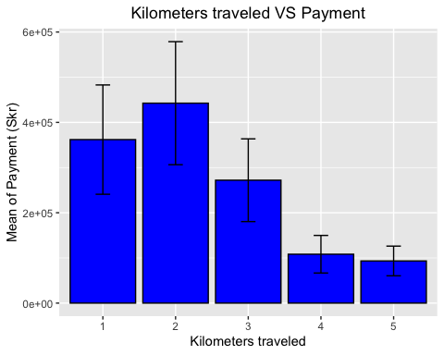

The bar chart above shows the mean of payment for each level of traveled distance. The distribution is right-skewed. The mean of payment of Kilometres 1 to 3 vary between 200000 to 450000 skr, while that of kilometres 4 and 5 are around 100000 skr. The largest difference happens between Kilometres 2 and 5 (~350000 skr).

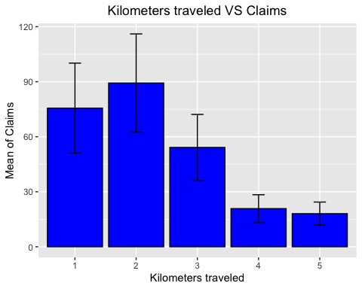

The bar chart above shows the mean of claim amount for each level of traveled distance. The distribution is right-skewed. The mean of claim amount of Kilometres 1 to 3 vary between 50 to 90 cases, while that of kilometres 4 and 5 are around 20 cases. The largest difference happens between Kilometres 2 and 5 (~70 cases).

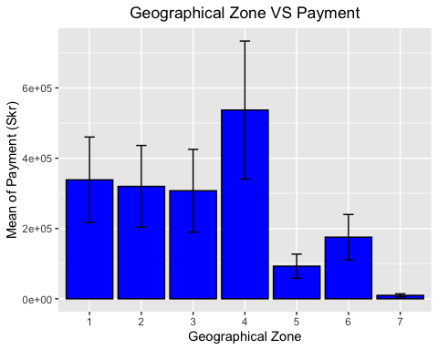

The bar chart above shows the mean of payment for each geographical zone. Zone 1 to 4 have mean of claim amount vary between 300000 to 550000 skr while Zone 5 to 7 have cases less than 200000 skr. The difference between Zone 4 and Zone 7 is around 500000 skr.

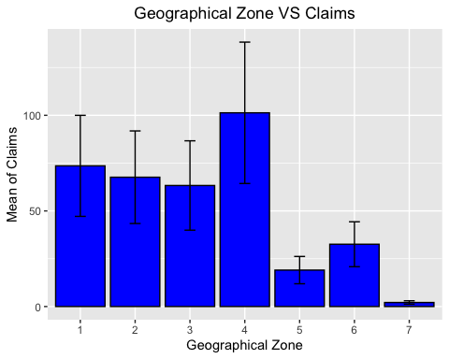

The bar chart above shows the mean of claim amount for each geographical zone. Zone 1 to 4 have mean of claim amount vary between 60 to 105 cases while Zone 5 to 7 have cases less than 40 cases. The difference between Zone 4 and Zone 7 is around 100 cases.

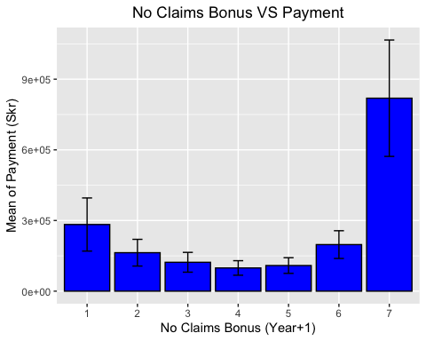

The bar chart above shows the mean of payment for no claims bonus of different number of years. It presents a U-shape distribution, with the mean claims of 6 years of bonus (7) particularly higher than the others (~800000 skr, nearly 500000 skr more than the next highest year).

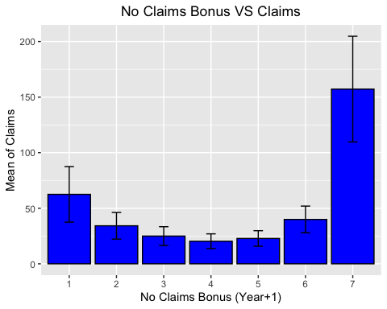

The bar chart above shows the mean of claim amount for no claims bonus of different number of years. It presents a U-shape distribution, with the mean claims of 6 years of bonus (7) particularly higher than the others (~150 cases, nearly 100 cases more than the next highest year).

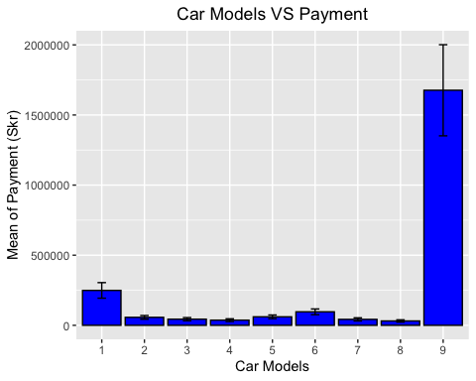

The bar chart above shows the mean of payment for each class of car models. It indicates that all classes are close in mean claims except for class9, of which the mean of payment is particularly high (~1700000 skr).

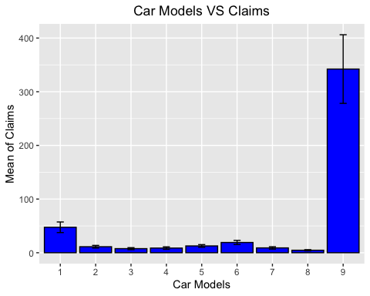

The bar chart above shows the mean of claim amount for each class of car models. It indicates that all classes are close in mean claims except for class9, of which the mean of claim amount is particularly high (~350 cases).

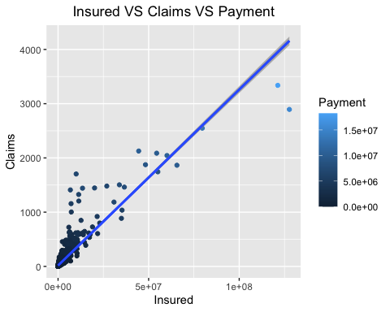

The scatter plot above shows the relationship between insured amount, claim amount and payment. The upward linear line indicates a positive relationship between them. While most data points cluster near 0 (dark blue: small payment), there are several data points that sit remotely from the majority (light blue: large payment). The 95% confidence interval (shaded area) is very small (close to the line) indicating a small standard deviation.

Let’s have an analysis (***central tendency*** and ***dispersion measures***) on our data set:

## Kilometres Zone Bonus Make Insured Claims   
## 1:439 1:315 1:307 1 :245 Min. : 10 Min. : 0.00   
## 2:441 2:315 2:312 2 :245 1st Qu.: 21610 1st Qu.: 1.00   
## 3:441 3:315 3:310 9 :245 Median : 81525 Median : 5.00   
## 4:434 4:315 4:310 5 :244 Mean : 1092195 Mean : 51.87   
## 5:427 5:313 5:313 6 :244 3rd Qu.: 389782 3rd Qu.: 21.00   
## 6:315 6:315 3 :242 Max. :127687270 Max. :3338.00   
## 7:294 7:315 (Other):717   
## Payment   
## Min. : 0   
## 1st Qu.: 2989   
## Median : 27404   
## Mean : 257008   
## 3rd Qu.: 111954   
## Max. :18245026   
##

For insured amount:  
the 1st quartile is 21610 while the 3rd quartile is 389782, the interquartile range is 389782 - 21610 = 368172  
The minimum value is 10 while the maximum value is 127687270, the range is 127687270 - 10 = 127687260  
The median is 81525 and the mean is 1092195

For claim amount:  
the 1st quartile is 1 while the 3rd quartile is 21, the interquartile range is 21 - 1 = 20  
The minimum value is 0 while the maximum value is 3338, the range is 3338 - 0 = 3338  
The median is 5 and the mean is 51.87

For payment:  
the 1st quartile is 2989 while the 3rd quartile is 111954, the interquartile range is 111954 - 2989 = 108965  
The minimum value is 0 while the maximum value is 18245026, the range is 18245026 - 0 = 18245026  
The median is 27404 and the mean is 257008

## Correlation Analysis

We have 4 regular categorical variables and 3 continuous variables. Since we cannot use regular categorical variables in correlation analysis, we will only focus on our continuous variables. Before we perform correlation analysis to answer the question, let’s analyze again the last graph (scatter plot) in the answer to question A (Please refer to Question A).

It shows outliers so it does not pass the assumption of Pearson method. However, it shows monotonic relationship (positive) among variables and our data set is not small. Therefore, we will use Spearman method rather than Kendall method.

The correlation analysis is as below:

## Insured Claims Payment  
## Insured 1.0000000 0.9333367 0.9030321  
## Claims 0.9333367 1.0000000 0.9624433  
## Payment 0.9030321 0.9624433 1.0000000

The correlation coefficients of “Insured” and “Claims” against “Payment” are 0.90 and 0.96 respectively, both indicating a large effect on “Payment”. Therefore, we can say that total payment is highly related to both the number of claims and the number of insured policy years.

## Find the variables affecting payment by setting up a regression model

Regarding the predictors, since “Insured” and “Claims” have very strong correlation (as seen in the correlation analysis for question B) and that may bias our model (multicollinearity), I will not put them together. I will develop separated regression models using either “Insured” and Claims" to go along with other predictors to see their effects on “Payment”.

***Hierarchical method***

We develop our first model with “Claims”. We assume “Claims” is highly important, so we use it as the first predictor:

##   
## Call:  
## lm(formula = Payment ~ Claims, data = Insurance)  
##   
## Residuals:  
## Min 1Q Median 3Q Max   
## -1744858 -8545 2773 13386 1491369   
##   
## Coefficients:  
## Estimate Std. Error t value Pr(>|t|)   
## (Intercept) -3362.29 2154.79 -1.56 0.119   
## Claims 5020.08 10.35 485.11 <2e-16 ***  
## ---  
## Signif. codes: 0 '***' 0.001 '**' 0.01 '*' 0.05 '.' 0.1 ' ' 1  
##   
## Residual standard error: 97480 on 2180 degrees of freedom  
## Multiple R-squared: 0.9908, Adjusted R-squared: 0.9908   
## F-statistic: 2.353e+05 on 1 and 2180 DF, p-value: < 2.2e-16

Then we develop an advanced model by adding “Kilometres”, “Zone”, “Bonus”, and “Make” in one go:

##   
## Call:  
## lm(formula = Payment ~ Claims + Kilometres + Zone + Bonus + Make,   
## data = Insurance)  
##   
## Residuals:  
## Min 1Q Median 3Q Max   
## -1689350 -21772 -190 22648 1355764   
##   
## Coefficients:  
## Estimate Std. Error t value Pr(>|t|)   
## (Intercept) -62206.38 10030.98 -6.201 6.69e-10 ***  
## Claims 5059.74 12.41 407.870 < 2e-16 ***  
## Kilometres2 11382.14 6282.18 1.812 0.070154 .   
## Kilometres3 18546.92 6285.07 2.951 0.003202 **   
## Kilometres4 23612.52 6343.76 3.722 0.000203 ***  
## Kilometres5 22578.47 6376.93 3.541 0.000408 ***  
## Zone2 11471.87 7422.07 1.546 0.122337   
## Zone3 21010.68 7422.80 2.831 0.004690 **   
## Zone4 58181.21 7429.68 7.831 7.53e-15 ***  
## Zone5 30377.19 7465.22 4.069 4.89e-05 ***  
## Zone6 44410.61 7439.10 5.970 2.77e-09 ***  
## Zone7 33112.98 7618.77 4.346 1.45e-05 ***  
## Bonus2 23223.57 7495.38 3.098 0.001971 **   
## Bonus3 29502.51 7513.57 3.927 8.89e-05 ***  
## Bonus4 28679.63 7517.12 3.815 0.000140 ***  
## Bonus5 26319.68 7497.15 3.511 0.000456 ***  
## Bonus6 28548.14 7475.35 3.819 0.000138 ***  
## Bonus7 56743.88 7569.74 7.496 9.54e-14 ***  
## Make2 -8928.58 8427.41 -1.059 0.289505   
## Make3 -3955.68 8456.98 -0.468 0.640017   
## Make4 -16004.86 8494.05 -1.884 0.059666 .   
## Make5 -12543.28 8435.45 -1.487 0.137168   
## Make6 -9520.15 8431.60 -1.129 0.258980   
## Make7 -12209.93 8456.17 -1.444 0.148910   
## Make8 -1369.76 8507.61 -0.161 0.872105   
## Make9 -64246.26 9175.72 -7.002 3.36e-12 ***  
## ---  
## Signif. codes: 0 '***' 0.001 '**' 0.01 '*' 0.05 '.' 0.1 ' ' 1  
##   
## Residual standard error: 93140 on 2156 degrees of freedom  
## Multiple R-squared: 0.9917, Adjusted R-squared: 0.9916   
## F-statistic: 1.032e+04 on 25 and 2156 DF, p-value: < 2.2e-16

We then use ANOVA table to compare both models:

## Analysis of Variance Table  
##   
## Model 1: Payment ~ Claims  
## Model 2: Payment ~ Claims + Kilometres + Zone + Bonus + Make  
## Res.Df RSS Df Sum of Sq F Pr(>F)   
## 1 2180 2.0716e+13   
## 2 2156 1.8704e+13 24 2.0118e+12 9.6622 < 2.2e-16 ***  
## ---  
## Signif. codes: 0 '***' 0.001 '**' 0.01 '*' 0.05 '.' 0.1 ' ' 1

Overall, from both summary, we can tell that both models are significantly better than the mean model (p-value < 0.05). The original model has a higher F-ratio with only 1 DF. However, the advanced model is more representative with 24 DF and a 0.0008 larger adjusted R-squared, although both models have very high ratios of adjusted R-squared. Note that “Claims” has a particularly high t-value, which verifies the assumption we made in the beginning of Question C (we assume “Claims” is highly important). The anova table also suggests that the advanced model represents better for our data (p-value < 0.05).

Therefore, we will enter the testing section with our advanced model.

First we check for the number of ***standardized residual(s)*** with absolute value > 2.58:

## [1] 45

Since it includes more than 1% (45/2182*100% = 2.06%) of our observation, we need to remove some poor residuals.

The number of poor residuals (those that satisfy (A) Cook’s distance > 1.00, (B) standardized residuals with absolute value > 3.29, (C) hat values of greater than twice the average hat value):

## [1] 1

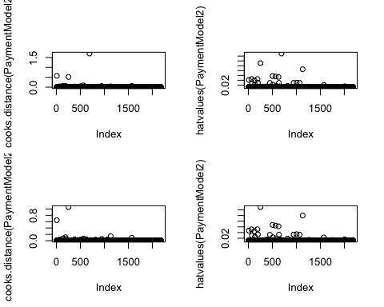

By looking at the initial ***Cook’s distance*** graph in the top-left, we can see most cases lie along 0.00 Cook’s distance while 1 case has Cook’s distance greater than 1.00 (that causes for concern).

By looking at the initial ***hat values*** graph in the top-right, we can see that the hat values of most cases sit close to 0.00 hv while 2-3 cases sit far away. We investigate all cases with hat values of greater than twice the average hat value.

The bottom graphs show the results after removal of poor residuals. The maximum of Cook’s distance is reduced from 1.70 to 0.57, while the maximum of hat value is reduced from 0.15 to 0.11.

Then we check whether autocorrelation of residual terms exists in our model by using ***DW test***:

##   
## Durbin-Watson test  
##   
## data: PaymentModel2  
## DW = 1.9602, p-value = 0.109  
## alternative hypothesis: true autocorrelation is greater than 0

A DW value of 1.96 indicates possible autocorrelation, though the effect could be very small.

After that, we use ***Variance Inflation Factor (VIF)*** to indicate whether a predictor has a strong linear relationship with other predictors:

## GVIF Df GVIF^(1/(2*Df))  
## Claims 1.608621 1 1.268314  
## Kilometres 1.036555 4 1.004498  
## Zone 1.046526 6 1.003797  
## Bonus 1.082664 6 1.006641  
## Make 1.457554 8 1.023827

## [1] 2.435933

No single predictor shows a strong linear relationship with other predictors (no VIF >= 10.00) but the average VIF of 2.44 indicates that there may be one or more collinear explanatories (average VIF > 1.00).

In regards of ***sample size***, we have a sample size of 2182, which is far more than the recommended minimum (50 + 5k, where k is the number of predictors) to test the overall fit of your regression model, which make our model more reliable.

Lastly, we check for ***linearity and homoscedasticity***:

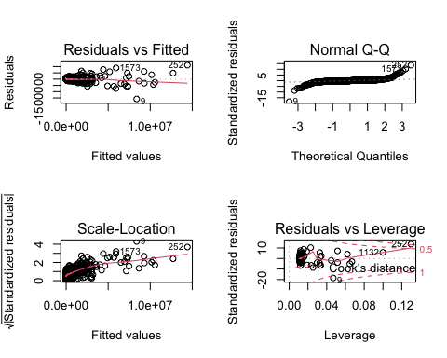

The top-left graph shows the relationship between the fitted values and the standardized residuals. We can see there is an acceptable linear curve. The data points are quite evenly dispersed around zero. This implies that the residuals at each level of the predictors have nearly the same variance (homoscedasticity).

At last, we update the summary of our regression model:

##   
## Call:  
## lm(formula = Payment ~ Claims + Kilometres + Zone + Bonus + Make,   
## data = Insurance)  
##   
## Residuals:  
## Min 1Q Median 3Q Max   
## -1581609 -21058 64 20886 1111063   
##   
## Coefficients:  
## Estimate Std. Error t value Pr(>|t|)   
## (Intercept) -51782.40 9455.64 -5.476 4.85e-08 ***  
## Claims 4980.51 12.59 395.695 < 2e-16 ***  
## Kilometres2 8877.60 5910.96 1.502 0.133272   
## Kilometres3 16878.54 5912.63 2.855 0.004350 **   
## Kilometres4 19190.03 5972.81 3.213 0.001333 **   
## Kilometres5 17839.41 6004.84 2.971 0.003003 **   
## Zone2 11001.02 6981.32 1.576 0.115224   
## Zone3 20196.75 6982.12 2.893 0.003859 **   
## Zone4 55313.56 6990.51 7.913 3.99e-15 ***  
## Zone5 26015.97 7026.66 3.702 0.000219 ***  
## Zone6 41162.92 6999.96 5.880 4.73e-09 ***  
## Zone7 27121.26 7175.17 3.780 0.000161 ***  
## Bonus2 21099.83 7051.36 2.992 0.002800 **   
## Bonus3 26593.48 7069.46 3.762 0.000173 ***  
## Bonus4 25423.03 7073.33 3.594 0.000333 ***  
## Bonus5 23326.20 7054.15 3.307 0.000959 ***  
## Bonus6 26957.64 7032.02 3.834 0.000130 ***  
## Bonus7 59379.76 7121.90 8.338 < 2e-16 ***  
## Make2 -11798.66 7928.74 -1.488 0.136874   
## Make3 -7153.68 7957.00 -0.899 0.368730   
## Make4 -19238.69 7991.90 -2.407 0.016156 *   
## Make5 -15327.06 7936.20 -1.931 0.053579 .   
## Make6 -11780.78 7931.99 -1.485 0.137631   
## Make7 -15326.80 7956.12 -1.926 0.054184 .   
## Make8 -4942.63 8005.16 -0.617 0.537016   
## Make9 -47401.86 8688.89 -5.455 5.45e-08 ***  
## ---  
## Signif. codes: 0 '***' 0.001 '**' 0.01 '*' 0.05 '.' 0.1 ' ' 1  
##   
## Residual standard error: 87610 on 2155 degrees of freedom  
## Multiple R-squared: 0.9914, Adjusted R-squared: 0.9913   
## F-statistic: 9989 on 25 and 2155 DF, p-value: < 2.2e-16

***b-values***  
All predictors have positive b-values (positive relationship with “Payment”), only all levels of “Make” don’t (negative relationship with “Payment”).

***t-test and p-values***  
As expected, “Claims” still has an extremely high t-ratio. All predictors (except “Kilometre2”, “Zone2”, and most levels of “Make”) are statistically significant (p-value < 0.05), meaning they contribute significantly to our ability to estimate values of the outcome “Payment”.

***R-squared***  
Adjusted R-squared drops 0.0004 to 0.9913 (still very close to 1.00), meaning that 99.13% of the variability in Payment is explained by Kilometres, Zone, Bonus, Make and Claims. Both R-squareds are nearly identical (0.0001 difference), meaning our model is capable to be generalized.

***F-stat and p-value***  
F-ratio drops from 10320 to 9989, and a corresponding p-value less than 0.05 (our model is significantly better than the mean model, therefore reject H0).

***Our conclusion*** According to our regression model, we can respond to the question that in our survey of 2182 cases, distance, location, bonus year, car model and claim amount all have significant relationships to insurance payment.

After we go with “Claims”, now we develop our second model with “Insured”.

We assume “Insured” is highly important, so we use it as the first predictor in our second model:

##   
## Call:  
## lm(formula = Payment ~ Insured, data = Insurance)  
##   
## Residuals:  
## Min 1Q Median 3Q Max   
## -5946157 -75828 -70260 -30246 5343552   
##   
## Coefficients:  
## Estimate Std. Error t value Pr(>|t|)   
## (Intercept) 7.385e+04 7.971e+03 9.265 <2e-16 ***  
## Insured 1.677e-01 1.383e-03 121.266 <2e-16 ***  
## ---  
## Signif. codes: 0 '***' 0.001 '**' 0.01 '*' 0.05 '.' 0.1 ' ' 1  
##   
## Residual standard error: 365600 on 2180 degrees of freedom  
## Multiple R-squared: 0.8709, Adjusted R-squared: 0.8708   
## F-statistic: 1.471e+04 on 1 and 2180 DF, p-value: < 2.2e-16

Then we develop an advanced model by adding “Kilometres”, “Zone”, “Bonus”, and “Make” in one go:

##   
## Call:  
## lm(formula = Payment ~ Insured + Kilometres + Zone + Bonus +   
## Make, data = Insurance)  
##   
## Residuals:  
## Min 1Q Median 3Q Max   
## -4705483 -76427 -4655 61437 4639327   
##   
## Coefficients:  
## Estimate Std. Error t value Pr(>|t|)   
## (Intercept) 2.923e+05 3.376e+04 8.657 < 2e-16 ***  
## Insured 1.535e-01 1.373e-03 111.808 < 2e-16 ***  
## Kilometres2 8.337e+04 2.129e+04 3.916 9.30e-05 ***  
## Kilometres3 2.674e+04 2.132e+04 1.255 0.209764   
## Kilometres4 -3.488e+04 2.148e+04 -1.624 0.104464   
## Kilometres5 -3.463e+04 2.159e+04 -1.604 0.108809   
## Zone2 -4.857e+04 2.517e+04 -1.930 0.053739 .   
## Zone3 -8.112e+04 2.517e+04 -3.223 0.001288 **   
## Zone4 -5.516e+04 2.527e+04 -2.183 0.029133 *   
## Zone5 -1.467e+05 2.522e+04 -5.818 6.84e-09 ***  
## Zone6 -1.272e+05 2.517e+04 -5.053 4.73e-07 ***  
## Zone7 -1.864e+05 2.567e+04 -7.259 5.43e-13 ***  
## Bonus2 -1.047e+05 2.539e+04 -4.125 3.85e-05 ***  
## Bonus3 -1.386e+05 2.543e+04 -5.451 5.58e-08 ***  
## Bonus4 -1.567e+05 2.543e+04 -6.163 8.51e-10 ***  
## Bonus5 -1.563e+05 2.537e+04 -6.162 8.55e-10 ***  
## Bonus6 -1.226e+05 2.534e+04 -4.840 1.39e-06 ***  
## Bonus7 -8.646e+04 2.597e+04 -3.329 0.000886 ***  
## Make2 -7.424e+04 2.855e+04 -2.600 0.009385 **   
## Make3 -8.689e+04 2.865e+04 -3.033 0.002448 **   
## Make4 -1.084e+05 2.877e+04 -3.769 0.000168 ***  
## Make5 -7.293e+04 2.858e+04 -2.552 0.010790 *   
## Make6 -8.356e+04 2.857e+04 -2.925 0.003483 **   
## Make7 -8.926e+04 2.865e+04 -3.116 0.001857 **   
## Make8 -8.780e+04 2.881e+04 -3.047 0.002337 **   
## Make9 4.990e+05 2.972e+04 16.792 < 2e-16 ***  
## ---  
## Signif. codes: 0 '***' 0.001 '**' 0.01 '*' 0.05 '.' 0.1 ' ' 1  
##   
## Residual standard error: 315800 on 2156 degrees of freedom  
## Multiple R-squared: 0.9047, Adjusted R-squared: 0.9036   
## F-statistic: 818.9 on 25 and 2156 DF, p-value: < 2.2e-16

We then use ANOVA table to compare both models:

## Analysis of Variance Table  
##   
## Model 1: Payment ~ Insured  
## Model 2: Payment ~ Insured + Kilometres + Zone + Bonus + Make  
## Res.Df RSS Df Sum of Sq F Pr(>F)   
## 1 2180 2.9140e+14   
## 2 2156 2.1504e+14 24 7.6353e+13 31.896 < 2.2e-16 ***  
## ---  
## Signif. codes: 0 '***' 0.001 '**' 0.01 '*' 0.05 '.' 0.1 ' ' 1

Overall, from both summary, we can tell that both models are significantly better than the mean model (p-value < 0.05). The original model has a higher F-ratio with only 1 DF. However, the advanced model is more representative with 24 DF and a 0.0328 larger adjusted R-squared, although both models have very high ratios of adjusted R-squared. Note that “Insured” has a particularly high t-value, which verifies the assumption we made in the beginning of Question C (we assume “Insured” is highly important). The anova table also suggests that the advanced model represents better for our data (p-value < 0.05).

Therefore, we will enter the testing section with our advanced model.

First we check for the number of ***standardized residual(s)*** with absolute value > 2.58:

## [1] 28

Since it includes more than 1% (28/2182*100% = 1.28%) of our observation, we need to remove some poor residuals.

The number of poor residuals (those that satisfy (A) Cook’s distance > 1.00, (B) standardized residuals with absolute value > 3.29, (C) hat values of greater than twice the average hat value):

## [1] 1

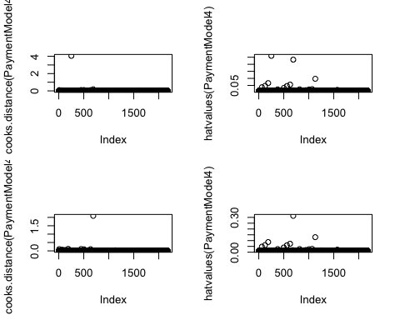

By looking at the initial ***Cook’s distance*** graph in the top-left, we can see most cases lie along 0.00 Cook’s distance while 1 case has Cook’s distance greater than 1.00 (that causes for concern).

By looking at the initial ***hat values*** graph in the top-right, we can see that the hat values of most cases sit close to 0.00 hv while 2 cases sit far away. We investigate all cases with hat values of greater than twice the average hat value.

The bottom graphs show the results after removal of poor residuals. The maximum of Cook’s distance is reduced from 4.05 to 0.19, while the maximum of hat value is reduced from 0.26 to 0.23.

Then we check whether autocorrelation of residual terms exists in our model by using ***DW test***:

##   
## Durbin-Watson test  
##   
## data: PaymentModel4  
## DW = 1.9655, p-value = 0.1338  
## alternative hypothesis: true autocorrelation is greater than 0

A DW value of 1.97 indicates possible autocorrelation, though the effect could be very small.

After that, we use ***Variance Inflation Factor (VIF)*** to indicate whether a predictor has a strong linear relationship with other predictors:

## GVIF Df GVIF^(1/(2*Df))  
## Insured 1.359060 1 1.165787  
## Kilometres 1.023661 4 1.002927  
## Zone 1.029572 6 1.002432  
## Bonus 1.099418 6 1.007930  
## Make 1.218222 8 1.012413

## [1] 2.394761

No single predictor shows a strong linear relationship with other predictors (no VIF >= 10.00) but the average VIF of 2.39 indicates that there may be one or more collinear explanatories (average VIF > 1.00).

In regards of ***sample size***, we have a sample size of 2182, which is far more than the recommended minimum (50 + 5k, where k is the number of predictors) to test the overall fit of your regression model, which make our model more reliable.

Lastly, we check for ***linearity and homoscedasticity***:

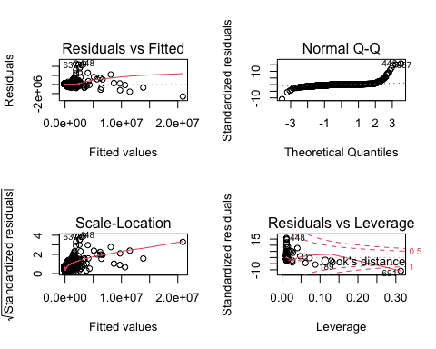

The top-left graph shows the relationship between the fitted values and the standardized residuals. We can see there is an acceptable linear curve. The data points are quite unevenly dispersed around zero. We may say that the residuals at each level of the predictors do not have the same variance (heteroscedasticity).

At last, we update the summary of our regression model:

##   
## Call:  
## lm(formula = Payment ~ Insured + Kilometres + Zone + Bonus +   
## Make, data = Insurance)  
##   
## Residuals:  
## Min 1Q Median 3Q Max   
## -2652372 -70012 -1935 60585 4627207   
##   
## Coefficients:  
## Estimate Std. Error t value Pr(>|t|)   
## (Intercept) 2.827e+05 3.134e+04 9.019 < 2e-16 ***  
## Insured 1.672e-01 1.472e-03 113.597 < 2e-16 ***  
## Kilometres2 6.895e+04 1.978e+04 3.486 0.000499 ***  
## Kilometres3 2.254e+04 1.978e+04 1.139 0.254703   
## Kilometres4 -2.922e+04 1.993e+04 -1.466 0.142848   
## Kilometres5 -2.697e+04 2.004e+04 -1.346 0.178505   
## Zone2 -5.126e+04 2.336e+04 -2.195 0.028288 *   
## Zone3 -8.562e+04 2.336e+04 -3.665 0.000253 ***  
## Zone4 -5.775e+04 2.345e+04 -2.463 0.013866 *   
## Zone5 -1.376e+05 2.341e+04 -5.878 4.80e-09 ***  
## Zone6 -1.239e+05 2.336e+04 -5.306 1.23e-07 ***  
## Zone7 -1.713e+05 2.384e+04 -7.187 9.11e-13 ***  
## Bonus2 -1.042e+05 2.356e+04 -4.420 1.04e-05 ***  
## Bonus3 -1.371e+05 2.360e+04 -5.810 7.16e-09 ***  
## Bonus4 -1.547e+05 2.360e+04 -6.556 6.88e-11 ***  
## Bonus5 -1.557e+05 2.355e+04 -6.613 4.74e-11 ***  
## Bonus6 -1.273e+05 2.352e+04 -5.411 6.95e-08 ***  
## Bonus7 -1.234e+05 2.418e+04 -5.104 3.62e-07 ***  
## Make2 -6.365e+04 2.651e+04 -2.402 0.016412 *   
## Make3 -7.589e+04 2.659e+04 -2.854 0.004358 **   
## Make4 -9.807e+04 2.670e+04 -3.673 0.000246 ***  
## Make5 -6.238e+04 2.653e+04 -2.351 0.018807 *   
## Make6 -7.724e+04 2.652e+04 -2.913 0.003621 **   
## Make7 -7.826e+04 2.659e+04 -2.943 0.003283 **   
## Make8 -7.487e+04 2.675e+04 -2.799 0.005168 **   
## Make9 4.417e+05 2.775e+04 15.915 < 2e-16 ***  
## ---  
## Signif. codes: 0 '***' 0.001 '**' 0.01 '*' 0.05 '.' 0.1 ' ' 1  
##   
## Residual standard error: 293100 on 2155 degrees of freedom  
## Multiple R-squared: 0.9085, Adjusted R-squared: 0.9074   
## F-statistic: 855.9 on 25 and 2155 DF, p-value: < 2.2e-16

***b-values***  
Only “Insured”, “Kilometres2”, “Kilometres3” and “Make9” have positive b-values (positive relationship with “Payment”), the b-values of other predictors are negeative (negative relationship with “Payment”).

***t-test and p-values***  
As expected, “Insured” has an extremely high t-ratio. All predictors (except “Kilometre3”, “Kilometre4” and “Kilometre5”) are statistically significant (p-value < 0.05), meaning they contribute significantly to our ability to estimate values of the outcome “Payment”.

***R-squared***  
Adjusted R-squared rises 0.0038 to 0.9074 (still very close to 1.00), meaning that 90.74% of the variability in Payment is explained by Kilometres, Zone, Bonus, Make and Insured. Both R-squareds do not have a large difference (0.0011 difference), meaning our model is capable to be generalized.

***F-stat and p-value***  
F-ratio rises from 818.9 to 855.9, and a corresponding p-value less than 0.05 (our model is significantly better than the mean model, therefore reject H0).

***Our conclusion***  
According to our regression model, we can respond to the question that in our survey of 2182 cases, distance, location, bonus year, car model and insured amount all have significant relationships to insurance payment. However, compared to the first model, where adjusted R-squared is 0.9913, this model is less representative to the our data and therefore we prefer the first model.

## Find the variables affecting claim rates by setting up a regression model

This time, I will use ***stepwise regression modeling*** in ***both directions***:

## Start: AIC=23160.03  
## Claims ~ 1  
##   
## Df Sum of Sq RSS AIC  
## + Insured 1 73540770 15198022 19312  
## + Make 8 23594134 65144658 22502  
## + Bonus 6 4469115 84269677 23059  
## + Zone 6 2220038 86518754 23117  
## + Kilometres 4 1774202 86964590 23124  
## <none> 88738792 23160  
##   
## Step: AIC=19311.82  
## Claims ~ Insured  
##   
## Df Sum of Sq RSS AIC  
## + Make 8 3126865 12071157 18825  
## + Zone 6 359554 14838468 19272  
## + Bonus 6 335468 14862553 19275  
## + Kilometres 4 143786 15054235 19299  
## <none> 15198022 19312  
## - Insured 1 73540770 88738792 23160  
##   
## Step: AIC=18825.2  
## Claims ~ Insured + Make  
##   
## Df Sum of Sq RSS AIC  
## + Zone 6 424979 11646178 18759  
## + Bonus 6 302253 11768904 18782  
## + Kilometres 4 210824 11860333 18795  
## <none> 12071157 18825  
## - Make 8 3126865 15198022 19312  
## - Insured 1 53073501 65144658 22502  
##   
## Step: AIC=18759  
## Claims ~ Insured + Make + Zone  
##   
## Df Sum of Sq RSS AIC  
## + Bonus 6 297990 11348188 18714  
## + Kilometres 4 224980 11421198 18724  
## <none> 11646178 18759  
## - Zone 6 424979 12071157 18825  
## - Make 8 3192290 14838468 19272  
## - Insured 1 51178355 62824533 22434  
##   
## Step: AIC=18714.44  
## Claims ~ Insured + Make + Zone + Bonus  
##   
## Df Sum of Sq RSS AIC  
## + Kilometres 4 224352 11123836 18679  
## <none> 11348188 18714  
## - Bonus 6 297990 11646178 18759  
## - Zone 6 420715 11768904 18782  
## - Make 8 3162689 14510877 19235  
## - Insured 1 46946083 58294272 22283  
##   
## Step: AIC=18678.87  
## Claims ~ Insured + Make + Zone + Bonus + Kilometres  
##   
## Df Sum of Sq RSS AIC  
## <none> 11123836 18679  
## - Kilometres 4 224352 11348188 18714  
## - Bonus 6 297362 11421198 18724  
## - Zone 6 435392 11559228 18751  
## - Make 8 3241285 14365121 19221  
## - Insured 1 45249641 56373477 22218

##   
## Call:  
## lm(formula = Claims ~ Insured + Make + Zone + Bonus + Kilometres,   
## data = Insurance)  
##   
## Coefficients:  
## (Intercept) Insured Make2 Make3 Make4 Make5   
## 7.130e+01 2.924e-05 -1.375e+01 -1.727e+01 -1.911e+01 -1.278e+01   
## Make6 Make7 Make8 Make9 Zone2 Zone3   
## -1.514e+01 -1.611e+01 -1.813e+01 1.180e+02 -1.165e+01 -1.983e+01   
## Zone4 Zone5 Zone6 Zone7 Bonus2 Bonus3   
## -2.059e+01 -3.574e+01 -3.416e+01 -4.461e+01 -2.533e+01 -3.334e+01   
## Bonus4 Bonus5 Bonus6 Bonus7 Kilometres2 Kilometres3   
## -3.679e+01 -3.614e+01 -2.950e+01 -2.374e+01 1.423e+01 8.060e-01   
## Kilometres4 Kilometres5   
## -1.317e+01 -1.309e+01

The model suggests a formula that includes “Claims” as the output and “Insured”, “Zone”, “Kilometres”, “Bonus” and “Make” as the predictors.

Then we take a look at the summary of our model:

##   
## Call:  
## lm(formula = Claims ~ Insured + Zone + Kilometres + Bonus + Make,   
## data = Insurance)  
##   
## Residuals:  
## Min 1Q Median 3Q Max   
## -983.95 -16.36 0.06 14.09 1222.44   
##   
## Coefficients:  
## Estimate Std. Error t value Pr(>|t|)   
## (Intercept) 7.130e+01 7.679e+00 9.284 < 2e-16 ***  
## Insured 2.924e-05 3.122e-07 93.649 < 2e-16 ***  
## Zone2 -1.165e+01 5.724e+00 -2.036 0.041887 *   
## Zone3 -1.983e+01 5.724e+00 -3.464 0.000543 ***  
## Zone4 -2.059e+01 5.747e+00 -3.583 0.000347 ***  
## Zone5 -3.574e+01 5.737e+00 -6.230 5.60e-10 ***  
## Zone6 -3.416e+01 5.724e+00 -5.969 2.79e-09 ***  
## Zone7 -4.461e+01 5.839e+00 -7.641 3.23e-14 ***  
## Kilometres2 1.423e+01 4.843e+00 2.938 0.003341 **   
## Kilometres3 8.060e-01 4.848e+00 0.166 0.867982   
## Kilometres4 -1.317e+01 4.884e+00 -2.697 0.007057 **   
## Kilometres5 -1.309e+01 4.910e+00 -2.666 0.007737 **   
## Bonus2 -2.533e+01 5.775e+00 -4.385 1.21e-05 ***  
## Bonus3 -3.334e+01 5.784e+00 -5.765 9.35e-09 ***  
## Bonus4 -3.679e+01 5.784e+00 -6.361 2.44e-10 ***  
## Bonus5 -3.614e+01 5.771e+00 -6.263 4.55e-10 ***  
## Bonus6 -2.950e+01 5.763e+00 -5.119 3.35e-07 ***  
## Bonus7 -2.374e+01 5.907e+00 -4.019 6.03e-05 ***  
## Make2 -1.375e+01 6.494e+00 -2.117 0.034346 *   
## Make3 -1.727e+01 6.515e+00 -2.651 0.008088 **   
## Make4 -1.911e+01 6.543e+00 -2.921 0.003523 **   
## Make5 -1.278e+01 6.501e+00 -1.966 0.049478 *   
## Make6 -1.514e+01 6.498e+00 -2.330 0.019899 *   
## Make7 -1.611e+01 6.515e+00 -2.473 0.013469 *   
## Make8 -1.813e+01 6.553e+00 -2.767 0.005712 **   
## Make9 1.180e+02 6.759e+00 17.451 < 2e-16 ***  
## ---  
## Signif. codes: 0 '***' 0.001 '**' 0.01 '*' 0.05 '.' 0.1 ' ' 1  
##   
## Residual standard error: 71.83 on 2156 degrees of freedom  
## Multiple R-squared: 0.8746, Adjusted R-squared: 0.8732   
## F-statistic: 601.7 on 25 and 2156 DF, p-value: < 2.2e-16

Overall, according to the summary, we can tell that our model is significantly better than the mean model (p-value < 0.05). Most predictors are statistically significant (p-value < 0.05). Note that “Insured” has a particularly high t-value, which indicates its large contribution to our ability to estimate values of the outcome. Our model also has a good value of multiple R-squared (0.8746), which indicates the predictors explain 87.46% of the variance in “Claims” collectively in our sample.

Now we will enter the testing section.

First we check for the number of ***standardized residual(s)*** with absolute value > 2.58:

## [1] 29

Since it includes more than 1% (29/2182*100% = 1.33%) of our observation, we need to remove some poor residuals.

The number of poor residuals (those that satisfy (A) Cook’s distance > 1.00, (B) standardized residuals with absolute value > 3.29, (C) hat values of greater than twice the average hat value):

## [1] 1

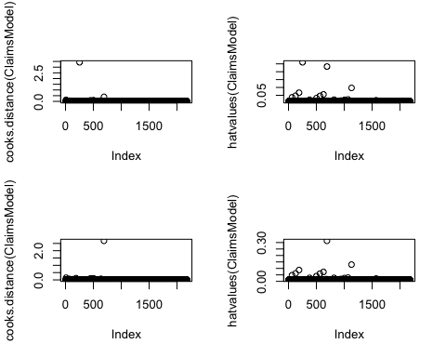

By looking at the initial ***Cook’s distance*** graph in the top-left, we can see most cases lie along 0.00 Cook’s distance while 1 case has Cook’s distance greater than 1.00 (that causes for concern).

By looking at the initial ***hat values*** graph in the top-right, we can see that the hat values of most cases sit close to 0hv while 2 cases sit far away. We investigate all cases with hat values of greater than twice the average hat value.

The bottom graphs show the results after removal of poor residuals. The maximum of Cook’s distance is reduced from 3.42 to 0.40, while the maximum of hat value is reduced from 0.26 to 0.23.

Then we check whether autocorrelation of residual terms exists in our model by using ***DW test***:

##   
## Durbin-Watson test  
##   
## data: ClaimsModel  
## DW = 1.9951, p-value = 0.3379  
## alternative hypothesis: true autocorrelation is greater than 0

A DW value of 2.00 indicates no autocorrelation in our model.

After that, we use ***Variance Inflation Factor (VIF)*** to indicate whether a predictor has a strong linear relationship with other predictors:

## GVIF Df GVIF^(1/(2*Df))  
## Insured 1.359060 1 1.165787  
## Zone 1.029572 6 1.002432  
## Kilometres 1.023661 4 1.002927  
## Bonus 1.099418 6 1.007930  
## Make 1.218222 8 1.012413

## [1] 2.394761

No single predictor shows a strong linear relationship with other predictors (no VIF >= 10.00) but the average VIF of 2.39 indicates that there may be one or more collinear explanatories (average VIF > 1.00).

In regards of ***sample size***, we have a sample size of 2182, which is far more than the recommended minimum (50 + 5k, where k is the number of predictors) to test the overall fit of your regression model, which make our model more reliable.

Lastly, we check for ***linearity and homoscedasticity***:

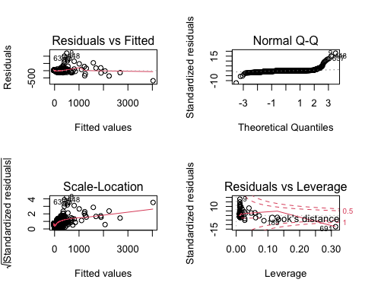

The top-left graph shows the relationship between the fitted values and the standardized residuals. We can see there is an acceptable linear curve. The data points are unequally dispersed around zero from x = 0 to 1000. This implies that the residuals at each level of the predictors may not have the same variance (heteroscedasticity).

At last, we update the summary of our regression model again:

##   
## Call:  
## lm(formula = Claims ~ Insured + Zone + Kilometres + Bonus + Make,   
## data = Insurance)  
##   
## Residuals:  
## Min 1Q Median 3Q Max   
## -691.29 -15.69 0.90 13.75 1207.65   
##   
## Coefficients:  
## Estimate Std. Error t value Pr(>|t|)   
## (Intercept) 6.928e+01 7.216e+00 9.601 < 2e-16 ***  
## Insured 3.212e-05 3.390e-07 94.736 < 2e-16 ***  
## Zone2 -1.222e+01 5.378e+00 -2.271 0.023226 *   
## Zone3 -2.077e+01 5.379e+00 -3.861 0.000116 ***  
## Zone4 -2.113e+01 5.400e+00 -3.913 9.38e-05 ***  
## Zone5 -3.383e+01 5.391e+00 -6.275 4.22e-10 ***  
## Zone6 -3.349e+01 5.378e+00 -6.227 5.69e-10 ***  
## Zone7 -4.147e+01 5.489e+00 -7.555 6.16e-14 ***  
## Kilometres2 1.121e+01 4.554e+00 2.462 0.013898 *   
## Kilometres3 -7.296e-02 4.556e+00 -0.016 0.987224   
## Kilometres4 -1.199e+01 4.590e+00 -2.612 0.009071 **   
## Kilometres5 -1.149e+01 4.614e+00 -2.489 0.012871 *   
## Bonus2 -2.521e+01 5.426e+00 -4.645 3.60e-06 ***  
## Bonus3 -3.303e+01 5.435e+00 -6.078 1.43e-09 ***  
## Bonus4 -3.638e+01 5.435e+00 -6.694 2.76e-11 ***  
## Bonus5 -3.601e+01 5.422e+00 -6.641 3.93e-11 ***  
## Bonus6 -3.046e+01 5.415e+00 -5.626 2.09e-08 ***  
## Bonus7 -3.147e+01 5.569e+00 -5.652 1.80e-08 ***  
## Make2 -1.154e+01 6.103e+00 -1.890 0.058866 .   
## Make3 -1.497e+01 6.123e+00 -2.445 0.014566 *   
## Make4 -1.695e+01 6.149e+00 -2.756 0.005900 **   
## Make5 -1.057e+01 6.110e+00 -1.730 0.083721 .   
## Make6 -1.382e+01 6.106e+00 -2.263 0.023744 *   
## Make7 -1.381e+01 6.123e+00 -2.256 0.024181 *   
## Make8 -1.543e+01 6.159e+00 -2.505 0.012327 *   
## Make9 1.060e+02 6.390e+00 16.582 < 2e-16 ***  
## ---  
## Signif. codes: 0 '***' 0.001 '**' 0.01 '*' 0.05 '.' 0.1 ' ' 1  
##   
## Residual standard error: 67.49 on 2155 degrees of freedom  
## Multiple R-squared: 0.8783, Adjusted R-squared: 0.8769   
## F-statistic: 622.1 on 25 and 2155 DF, p-value: < 2.2e-16

***b-values***  
Only “Insured”, “Kilometres2” and “Make9” have positive b-values (positive relationship with “Claims”), all other predictors have negative b-values (negative relationship with “Claims”).

***t-test and p-values***  
As expected, “Insured” has an extremely high t-ratio. All predictors (except “Kilometre3”, “Make2”, and “Make5”) are statistically significant (p-value < 0.05), meaning they contribute significantly to our ability to estimate values of the outcome “Claims”.

***R-squared***  
Adjusted R-squared is 0.8769 (fairly close to 1.00), meaning that 87.69% of the variability in Claims is explained by Kilometres, Zone, Bonus, Make and Insured.

***F-stat and p-value***  
F-ratio is 622.1, and a corresponding p-value < 0.05 (our model is significantly better than the mean model, therefore reject H0).

***Our conclusion***  
According to our regression model, we can respond to the question that in our survey of 2182 cases, distance, location, bonus year, car model and insured amount all have significant relationships to claim amount.

In respond to what extent the predictors affect claims number, we can conclude that with all other predictors (independent variables) held constant, for every 1 unit increase in:

Insured, Claims increases by 69.28 cases

Zone2, Claims decreases by 12.22 cases

Zone3, Claims decreases by 20.77 cases

Zone4, Claims decreases by 21.13 cases

Zone5, Claims decreases by 33.83 cases

Zone6, Claims decreases by 33.49 cases

Zone7, Claims decreases by 41.47 cases

Kilometre2, Claims decreases by 11.21 cases

Kilometre4, Claims decreases by 11.99 cases

Kilometre5, Claims decreases by 11.49 cases

Bonus2, Claims decreases by 25.21 cases

Bonus3, Claims decreases by 33.03 cases

Bonus4, Claims decreases by 36.38 cases

Bonus5, Claims decreases by 36.01 cases

Bonus6, Claims decreases by 30.46 cases

Bonus7, Claims decreases by 31.47 cases

Make3, Claims decreases by 14.97 cases

Make4, Claims decreases by 16.95 cases

Make6, Claims decreases by 13.82 cases

Make7, Claims decreases by 13.81 cases

Make8, Claims decreases by 15.43 cases

Make9, Claims increases by 106.00 cases

## Find the location, kilometer, and bonus level their insured amount, claims, and payment get increased.

Where payment increases:

##   
## Call:  
## lm(formula = Payment ~ Claims + Kilometres + Zone + Bonus + Make,   
## data = Insurance)  
##   
## Residuals:  
## Min 1Q Median 3Q Max   
## -1581609 -21058 64 20886 1111063   
##   
## Coefficients:  
## Estimate Std. Error t value Pr(>|t|)   
## (Intercept) -51782.40 9455.64 -5.476 4.85e-08 ***  
## Claims 4980.51 12.59 395.695 < 2e-16 ***  
## Kilometres2 8877.60 5910.96 1.502 0.133272   
## Kilometres3 16878.54 5912.63 2.855 0.004350 **   
## Kilometres4 19190.03 5972.81 3.213 0.001333 **   
## Kilometres5 17839.41 6004.84 2.971 0.003003 **   
## Zone2 11001.02 6981.32 1.576 0.115224   
## Zone3 20196.75 6982.12 2.893 0.003859 **   
## Zone4 55313.56 6990.51 7.913 3.99e-15 ***  
## Zone5 26015.97 7026.66 3.702 0.000219 ***  
## Zone6 41162.92 6999.96 5.880 4.73e-09 ***  
## Zone7 27121.26 7175.17 3.780 0.000161 ***  
## Bonus2 21099.83 7051.36 2.992 0.002800 **   
## Bonus3 26593.48 7069.46 3.762 0.000173 ***  
## Bonus4 25423.03 7073.33 3.594 0.000333 ***  
## Bonus5 23326.20 7054.15 3.307 0.000959 ***  
## Bonus6 26957.64 7032.02 3.834 0.000130 ***  
## Bonus7 59379.76 7121.90 8.338 < 2e-16 ***  
## Make2 -11798.66 7928.74 -1.488 0.136874   
## Make3 -7153.68 7957.00 -0.899 0.368730   
## Make4 -19238.69 7991.90 -2.407 0.016156 *   
## Make5 -15327.06 7936.20 -1.931 0.053579 .   
## Make6 -11780.78 7931.99 -1.485 0.137631   
## Make7 -15326.80 7956.12 -1.926 0.054184 .   
## Make8 -4942.63 8005.16 -0.617 0.537016   
## Make9 -47401.86 8688.89 -5.455 5.45e-08 ***  
## ---  
## Signif. codes: 0 '***' 0.001 '**' 0.01 '*' 0.05 '.' 0.1 ' ' 1  
##   
## Residual standard error: 87610 on 2155 degrees of freedom  
## Multiple R-squared: 0.9914, Adjusted R-squared: 0.9913   
## F-statistic: 9989 on 25 and 2155 DF, p-value: < 2.2e-16

Recalling the above model developed in answer C, if all other predictors (independent variables) are held constant, each unit increase of the following variables has payment increases for (bolded = largest):

***Location*** Zone2: +11001.02 skr  
Zone3: +20196.75 skr  
**Zone4: +55313.56** skr  
Zone5: +26015.97 skr  
Zone6: +41162.92 skr  
Zone7: +27121.26 skr

***Kilometres***  
Kilometres2: +8877.60 skr  
Kilometres3: +16878.54 skr  
**Kilometres4: +19190.03** skr  
Kilometres5: +17839.41 skr

***Bonus level***  
Bonus2: +21099.83 skr  
Bonus3: +26593.48 skr  
Bonus4: +25423.03 skr  
Bonus5: +23326.20 skr  
Bonus6: +26957.64 skr  
***Bonus7: +59379.76 skr***

Where claim amount increases:

##   
## Call:  
## lm(formula = Claims ~ Insured + Zone + Kilometres + Bonus + Make,   
## data = Insurance)  
##   
## Residuals:  
## Min 1Q Median 3Q Max   
## -691.29 -15.69 0.90 13.75 1207.65   
##   
## Coefficients:  
## Estimate Std. Error t value Pr(>|t|)   
## (Intercept) 6.928e+01 7.216e+00 9.601 < 2e-16 ***  
## Insured 3.212e-05 3.390e-07 94.736 < 2e-16 ***  
## Zone2 -1.222e+01 5.378e+00 -2.271 0.023226 *   
## Zone3 -2.077e+01 5.379e+00 -3.861 0.000116 ***  
## Zone4 -2.113e+01 5.400e+00 -3.913 9.38e-05 ***  
## Zone5 -3.383e+01 5.391e+00 -6.275 4.22e-10 ***  
## Zone6 -3.349e+01 5.378e+00 -6.227 5.69e-10 ***  
## Zone7 -4.147e+01 5.489e+00 -7.555 6.16e-14 ***  
## Kilometres2 1.121e+01 4.554e+00 2.462 0.013898 *   
## Kilometres3 -7.296e-02 4.556e+00 -0.016 0.987224   
## Kilometres4 -1.199e+01 4.590e+00 -2.612 0.009071 **   
## Kilometres5 -1.149e+01 4.614e+00 -2.489 0.012871 *   
## Bonus2 -2.521e+01 5.426e+00 -4.645 3.60e-06 ***  
## Bonus3 -3.303e+01 5.435e+00 -6.078 1.43e-09 ***  
## Bonus4 -3.638e+01 5.435e+00 -6.694 2.76e-11 ***  
## Bonus5 -3.601e+01 5.422e+00 -6.641 3.93e-11 ***  
## Bonus6 -3.046e+01 5.415e+00 -5.626 2.09e-08 ***  
## Bonus7 -3.147e+01 5.569e+00 -5.652 1.80e-08 ***  
## Make2 -1.154e+01 6.103e+00 -1.890 0.058866 .   
## Make3 -1.497e+01 6.123e+00 -2.445 0.014566 *   
## Make4 -1.695e+01 6.149e+00 -2.756 0.005900 **   
## Make5 -1.057e+01 6.110e+00 -1.730 0.083721 .   
## Make6 -1.382e+01 6.106e+00 -2.263 0.023744 *   
## Make7 -1.381e+01 6.123e+00 -2.256 0.024181 *   
## Make8 -1.543e+01 6.159e+00 -2.505 0.012327 *   
## Make9 1.060e+02 6.390e+00 16.582 < 2e-16 ***  
## ---  
## Signif. codes: 0 '***' 0.001 '**' 0.01 '*' 0.05 '.' 0.1 ' ' 1  
##   
## Residual standard error: 67.49 on 2155 degrees of freedom  
## Multiple R-squared: 0.8783, Adjusted R-squared: 0.8769   
## F-statistic: 622.1 on 25 and 2155 DF, p-value: < 2.2e-16

Recalling the above model developed in answer D, if all other predictors (independent variables) are held constant, each unit increase of the following variables has claim amount increases for (bolded = largest):

***Location***  
No location has claim amount increases

***Kilometres***  
Only Kilometres2: +11.21 cases

***Bonus level***  
No bonus level has claim amount increases

For insured amount we do not have any developed model that targets it yet, so we will develop one below:

## Start: AIC=67857.44  
## Insured ~ 1  
##   
## Df Sum of Sq RSS AIC  
## + Claims 1 5.7927e+16 1.1971e+16 64009  
## + Make 8 9.8600e+15 6.0038e+16 67542  
## + Bonus 6 4.6236e+15 6.5275e+16 67720  
## + Zone 6 1.3270e+15 6.8571e+16 67828  
## + Kilometres 4 9.6712e+14 6.8931e+16 67835  
## <none> 6.9898e+16 67857  
##   
## Step: AIC=64009.23  
## Insured ~ Claims  
##   
## Df Sum of Sq RSS AIC  
## + Make 8 8.4632e+14 1.1125e+16 63865  
## + Bonus 6 4.5884e+14 1.1512e+16 63936  
## + Zone 6 2.1090e+14 1.1760e+16 63982  
## <none> 1.1971e+16 64009  
## + Kilometres 4 3.8754e+13 1.1932e+16 64010  
## - Claims 1 5.7927e+16 6.9898e+16 67857  
##   
## Step: AIC=63865.25  
## Insured ~ Claims + Make  
##   
## Df Sum of Sq RSS AIC  
## + Bonus 6 3.7655e+14 1.0748e+16 63802  
## + Zone 6 2.4903e+14 1.0876e+16 63828  
## + Kilometres 4 6.4214e+13 1.1061e+16 63861  
## <none> 1.1125e+16 63865  
## - Make 8 8.4632e+14 1.1971e+16 64009  
## - Claims 1 4.8913e+16 6.0038e+16 67542  
##   
## Step: AIC=63802.12  
## Insured ~ Claims + Make + Bonus  
##   
## Df Sum of Sq RSS AIC  
## + Zone 6 2.3871e+14 1.0510e+16 63765  
## + Kilometres 4 5.8343e+13 1.0690e+16 63798  
## <none> 1.0748e+16 63802  
## - Bonus 6 3.7655e+14 1.1125e+16 63865  
## - Make 8 7.6402e+14 1.1512e+16 63936  
## - Claims 1 4.4640e+16 5.5388e+16 67378  
##   
## Step: AIC=63765.11  
## Insured ~ Claims + Make + Bonus + Zone  
##   
## Df Sum of Sq RSS AIC  
## + Kilometres 4 6.3284e+13 1.0446e+16 63760  
## <none> 1.0510e+16 63765  
## - Zone 6 2.3871e+14 1.0748e+16 63802  
## - Bonus 6 3.6623e+14 1.0876e+16 63828  
## - Make 8 7.9855e+14 1.1308e+16 63909  
## - Claims 1 4.3477e+16 5.3987e+16 67334  
##   
## Step: AIC=63759.93  
## Insured ~ Claims + Make + Bonus + Zone + Kilometres  
##   
## Df Sum of Sq RSS AIC  
## <none> 1.0446e+16 63760  
## - Kilometres 4 6.3284e+13 1.0510e+16 63765  
## - Zone 6 2.4365e+14 1.0690e+16 63798  
## - Bonus 6 3.5976e+14 1.0806e+16 63822  
## - Make 8 8.2530e+14 1.1272e+16 63910  
## - Claims 1 4.2494e+16 5.2940e+16 67299

##   
## Call:  
## lm(formula = Insured ~ Claims + Make + Bonus + Zone + Kilometres,   
## data = Insurance)  
##   
## Coefficients:  
## (Intercept) Claims Make2 Make3 Make4 Make5   
## -1735451 27455 225840 315802 372456 199101   
## Make6 Make7 Make8 Make9 Bonus2 Bonus3   
## 324465 283138 308991 -2044802 688625 894692   
## Bonus4 Bonus5 Bonus6 Bonus7 Zone2 Zone3   
## 983131 985190 878785 1473402 358473 608836   
## Zone4 Zone5 Zone6 Zone7 Kilometres2 Kilometres3   
## 891521 849612 891918 1001851 -390831 -168778   
## Kilometres4 Kilometres5   
## 71465 38389

The model suggests a formula that includes “Insured” as the output and “Claims”, “Zone”, “Kilometres”, Bonus" and “Make” as the predictors.

Then we take a look at the summary of our model:

##   
## Call:  
## lm(formula = Insured ~ Claims + Zone + Kilometres + Bonus + Make,   
## data = Insurance)  
##   
## Residuals:  
## Min 1Q Median 3Q Max   
## -33005096 -369218 -37211 436161 49646999   
##   
## Coefficients:  
## Estimate Std. Error t value Pr(>|t|)   
## (Intercept) -1735450.8 237059.9 -7.321 3.46e-13 ***  
## Claims 27455.3 293.2 93.649 < 2e-16 ***  
## Zone2 358472.9 175404.2 2.044 0.041105 *   
## Zone3 608835.6 175421.4 3.471 0.000529 ***  
## Zone4 891520.6 175584.0 5.077 4.15e-07 ***  
## Zone5 849611.5 176423.8 4.816 1.57e-06 ***  
## Zone6 891918.1 175806.7 5.073 4.24e-07 ***  
## Zone7 1001851.3 180052.7 5.564 2.96e-08 ***  
## Kilometres2 -390830.6 148465.3 -2.632 0.008537 **   
## Kilometres3 -168777.9 148533.7 -1.136 0.255960   
## Kilometres4 71465.5 149920.6 0.477 0.633632   
## Kilometres5 38389.1 150704.6 0.255 0.798955   
## Bonus2 688624.7 177136.6 3.888 0.000104 ***  
## Bonus3 894692.4 177566.6 5.039 5.08e-07 ***  
## Bonus4 983130.8 177650.4 5.534 3.51e-08 ***  
## Bonus5 985190.1 177178.6 5.560 3.02e-08 ***  
## Bonus6 878785.0 176663.3 4.974 7.06e-07 ***  
## Bonus7 1473402.4 178894.0 8.236 3.05e-16 ***  
## Make2 225839.8 199163.2 1.134 0.256944   
## Make3 315801.7 199862.0 1.580 0.114231   
## Make4 372455.9 200738.0 1.855 0.063671 .   
## Make5 199100.6 199353.2 0.999 0.318036   
## Make6 324465.2 199262.2 1.628 0.103600   
## Make7 283137.5 199842.8 1.417 0.156686   
## Make8 308990.9 201058.4 1.537 0.124484   
## Make9 -2044802.0 216847.9 -9.430 < 2e-16 ***  
## ---  
## Signif. codes: 0 '***' 0.001 '**' 0.01 '*' 0.05 '.' 0.1 ' ' 1  
##   
## Residual standard error: 2201000 on 2156 degrees of freedom  
## Multiple R-squared: 0.8505, Adjusted R-squared: 0.8488   
## F-statistic: 490.8 on 25 and 2156 DF, p-value: < 2.2e-16

Now we will enter the testing section.

First we check for the number of ***standardized residual(s)*** with absolute value > 2.58:

## [1] 27

Since it includes more than 1% (27/2182*100% = 1.23%) of our observation, we need to remove some poor residuals.

The number of poor residuals (those that satisfy (A) Cook’s distance > 1.00, (B) standardized residuals with absolute value > 3.29, (C) hat values of greater than twice the average hat value):

## [1] 2

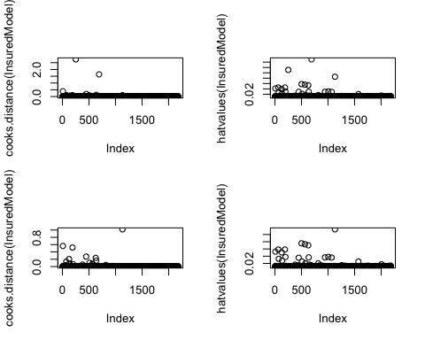

The upper graphs show before removal and bottom graphs show after removal of poor residuals. The maximum of Cook’s distance is reduced from 2.75 to 0.39, while the maximum of hat value is reduced from 0.15 to 0.09.

Then we check whether autocorrelation of residual terms exists in our model by using ***DW test***:

##   
## Durbin-Watson test  
##   
## data: InsuredModel  
## DW = 1.9747, p-value = 0.1854  
## alternative hypothesis: true autocorrelation is greater than 0

A DW value of 1.97 indicates no autocorrelation in our model.

After that, we use ***Variance Inflation Factor (VIF)*** to indicate whether a predictor has a strong linear relationship with other predictors:

## GVIF Df GVIF^(1/(2*Df))  
## Claims 1.637807 1 1.279768  
## Zone 1.047962 6 1.003912  
## Kilometres 1.038569 4 1.004742  
## Bonus 1.082684 6 1.006642  
## Make 1.486206 8 1.025073

## [1] 2.440891

No single predictor shows a strong linear relationship with other predictors (no VIF >= 10.00) but the average VIF of 2.44 indicates that there may be one or more collinear explanatories (average VIF > 1.00).

In regards of ***sample size***, we have a sample size of 2182, which is far more than the recommended minimum (50 + 5k, where k is the number of predictors) to test the overall fit of your regression model, which make our model more reliable.

Lastly, we check for ***linearity and homoscedasticity***:

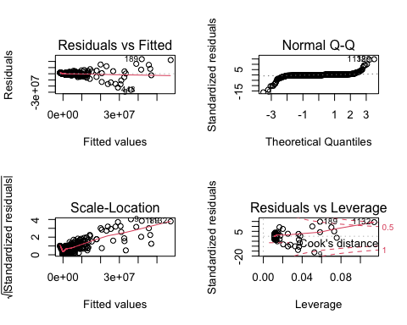

The top-left graph shows the relationship between the fitted values and the standardized residuals. We can see there is an excellent linear curve. The data points are equally dispersed around zero. This implies that the residuals at each level of the predictors may have the same variance (homoscedasticity).

At last, we update the summary of our regression model:

##   
## Call:  
## lm(formula = Insured ~ Claims + Zone + Kilometres + Bonus + Make,   
## data = Insurance)  
##   
## Residuals:  
## Min 1Q Median 3Q Max   
## -26139005 -239814 -33560 348589 23687512   
##   
## Coefficients:  
## Estimate Std. Error t value Pr(>|t|)   
## (Intercept) -1216744.1 178623.6 -6.812 1.25e-11 ***  
## Claims 22529.9 253.2 88.985 < 2e-16 ***  
## Zone2 329202.3 131755.4 2.499 0.0125 *   
## Zone3 558237.4 131772.5 4.236 2.37e-05 ***  
## Zone4 682811.9 131989.5 5.173 2.51e-07 ***  
## Zone5 578585.0 132697.5 4.360 1.36e-05 ***  
## Zone6 690025.9 132154.9 5.221 1.95e-07 ***  
## Zone7 629361.8 135574.7 4.642 3.66e-06 ***  
## Kilometres2 -284463.5 111651.6 -2.548 0.0109 *   
## Kilometres3 -130296.2 111607.0 -1.167 0.2432   
## Kilometres4 -61048.5 112724.4 -0.542 0.5882   
## Kilometres5 -113589.9 113332.0 -1.002 0.3163   
## Bonus2 556848.1 133096.6 4.184 2.98e-05 ***  
## Bonus3 714186.9 133456.2 5.351 9.65e-08 ***  
## Bonus4 780557.6 133539.4 5.845 5.83e-09 ***  
## Bonus5 799305.1 133169.7 6.002 2.28e-09 ***  
## Bonus6 780028.6 132722.7 5.877 4.83e-09 ***  
## Bonus7 1606935.4 134423.0 11.954 < 2e-16 ***  
## Make2 47421.8 149668.1 0.317 0.7514   
## Make3 116574.0 150209.6 0.776 0.4378   
## Make4 171820.5 150868.5 1.139 0.2549   
## Make5 26102.0 149806.7 0.174 0.8617   
## Make6 183988.6 149716.5 1.229 0.2192   
## Make7 89543.1 150190.5 0.596 0.5511   
## Make8 86733.0 151128.4 0.574 0.5661   
## Make9 -1036814.3 164913.3 -6.287 3.91e-10 ***  
## ---  
## Signif. codes: 0 '***' 0.001 '**' 0.01 '*' 0.05 '.' 0.1 ' ' 1  
##   
## Residual standard error: 1653000 on 2154 degrees of freedom  
## Multiple R-squared: 0.8505, Adjusted R-squared: 0.8488   
## F-statistic: 490.3 on 25 and 2154 DF, p-value: < 2.2e-16

In response to the question, if all other predictors (independent variables) are held constant, each unit increase of the following variables has insured amount increases for (bolded = largest):

***Location***  
Zone2: +329202.3 cases  
Zone3: +558237.4 cases  
Zone4: +682811.9 cases  
Zone5: +578585 cases  
***Zone6: +690025.9 cases***  
Zone7: +629361.8 cases

***Kilometres***  
No distance has insured amount increases

***Bonus level***  
Bonus2: +556848.1 cases  
Bonus3: +714186.9 cases  
Bonus4: +780557.6 cases  
Bonus5: +799305.1 cases  
Bonus6: +780028.6 cases  
***Bonus7: +1606935.4 cases***